**Data Communication and Computer Network**

**Assignment – 1**

**Components of Satellite Communication**

**Satellite Communication**

When we use artificial satellites to offer communication links on different parts of Earth, this whole process is what is called satellite communication. It falls under the branch of telecommunications and is one of the way various points on Earth can be extended the feature of communication. It is a global telecommunications system. Around 2000 artificial satellites are currently orbiting the Earth and relaying digital and analog signals that might carry voice, data, video, text, etc. from one point on Earth to another.

We all are users of satellite communication and we relay digital and analog signals daily in various forms, sometimes text, sometimes video, sometimes voice notes, etc. We do so by using our cell phones to communicate with one or more people or groups of people all across the globe. We use WhatsApp, twitter and various other social media platforms on a daily basis and in doing so we communicate using satellite communication.

**Components of Satellite Communication**

Satellite Communication consists of two main components: the **ground segment** which consists of fixed or mobile transmission, reception, and ancillary equipment, and the **space segment**, which mainly refers to the satellite itself. If we look into the lifecycle of a satellite link, then initially we will see how the uplinking (or transmission) of a signal takes place originating from an Earth station to a satellite. The next part is of the satellite where it receives and amplifies the signal and then finally it resends the signal back to the Earth station where it again is reamplified. Satellite receivers on the ground include direct-to-home (DTH) satellite equipment, mobile reception equipment in aircraft, satellite telephones, and handheld devices.

Below Image is taken from [*https://electronicsdesk.com/satellite-uplink.html*](https://electronicsdesk.com/satellite-uplink.html)and represents Uplink and Downlink in satellite communication:

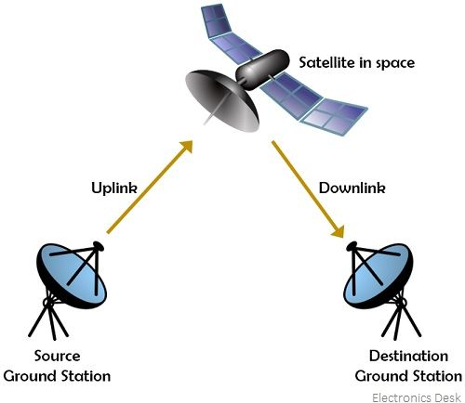 Figure-1

Now, Let’s dive deep into the various components of Satellite Communication. First we will talk about the Ground Segment.

**Ground Segment**

This is completely based on Earth surface area Terminals. Due to this, Ground segment is also called Earth segment. What it does is that it utilizes the communication capacity of the space segment. Ground segment has the power to access the satellite repeater in order to allow communication between users.

Note:- TTC & M ground stations are not included in ground segment.

Ground Segment Terminals

Fixed Terminals Transportable Mobile (In-Place) Terminals Terminals

1. Fixed Terminals: These terminals are fixed in place on the ground or Earth’s surface. These are the terminals which are designed for establishing a connection with the satellite. Fixed terminal as the name suggests are fixed on the ground and though they are providing numerous applications but there name is justified as they stay in place.

For Example: small terminals used in private network (VSATs), or terminals placed on residential buildings purposedly for receiving broadcast satellite signals.

Below is the image of VSAT representing the working and application of Fixed Terminals and this is referred from the website [*https://www.openpr.com/news/1941724/enterprise-vsat-very-small-aperture-terminal-system-market*](https://www.openpr.com/news/1941724/enterprise-vsat-very-small-aperture-terminal-system-market):

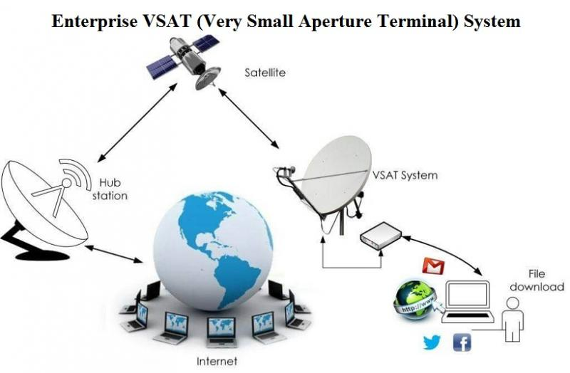 Figure - 2

2.Transport Terminals: These differ to the former terminals in a way as they can be transported i.e they are designed to be able to move. But note that, once they are on location, they need to be remained fixed or in place during transmission to the satellite.

For Example; Satellite news gathering (SGN) trucks which have to travel across to gather news from one region to another. So these trucks stop in one place, and deploy their antennas to establish connection or access the satellite link.

Below is the image of SNG Truck and how Transport Terminals communicate with satellites and this is referred from [*http://www.first.gr/services/satellite-internet/satellite-news-gathering*](http://www.first.gr/services/satellite-internet/satellite-news-gathering):

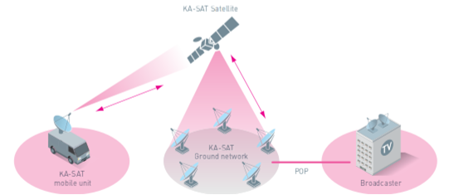 Figure-3

3. Mobile Terminals: Unlike the former terminals, these are designed to work while transporting or moving. They can communicate with the satellite all the time while travelling. They are also further classified as maritime mobile, land mobile or aeronautical mobile, depending on their locations on or near the Earth surface.

Below is the image of how Mobile Terminals operate and establish link with Satellite and is referred from [*https://link.springer.com/referenceworkentry/10.1007/978-3-319-23386-4_7*](https://link.springer.com/referenceworkentry/10.1007/978-3-319-23386-4_7):

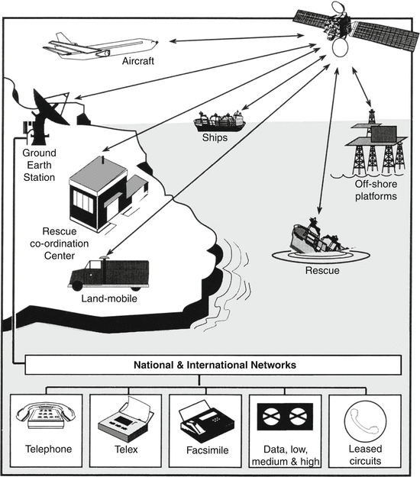 Figure - 4

Let’s move to the next component in satellite communication i.e. the Space Segment:

**Space Segment**

The Space segment is comprised of all the various satellite(s) in the orbit in the system. Now you might have a question as to who operates this segment. Well the answer to this has already been discussed above. Th full operational control of these satellites in the orbit is with the ground station. These ground stations are referred to as the Tracking, Telemetry, Command (TT&C) or the Tracking, Telemetry, Command and Monitoring (TTC&M) station. Now apart from just the operational control, one more aspect should be taken care of i.e. satellite’s safe orbiting and it’s management. TTC&M is responsible for providing this spacecraft control functions and management operations to ensure satellite following its trajectory and operating correctly. The TTC&M si also responsible for linking the satellite and ground. Note that, TTC&M link is different from user communication link.

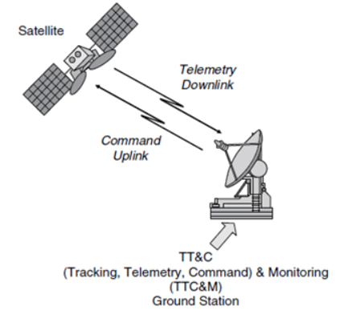 Figure – 5

TTC&M links might work in a similar frequency band or in different ones. TTC&M is most frequently achieved through a different earth terminal facility explicitly intended for its complex processes expected to maintain spacecraft in orbit.

There are other space segment subsystems apart from TTC&M, namely AOC Subsystem, Power and Antenna Subsystems and Transponders.

With the help of the below image you will get a better understanding of communication links between space and ground segments and how they operate and this image is referred from [*https://en.wikipedia.org/wiki/Ground_segment*](https://en.wikipedia.org/wiki/Ground_segment):

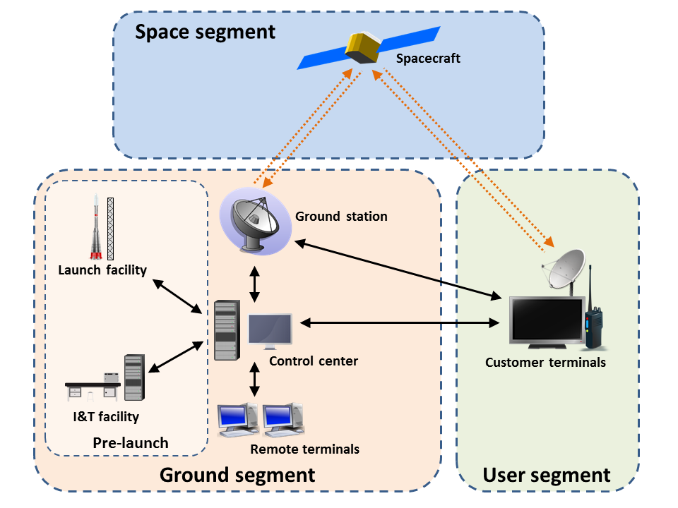Figure – 6

Now there’s one another segment in satellite communication i.e. the User segment. This segment is not directly involved in uplinking and downlinking but is the receiver end of this process.